For Immediate Release
Contact: Jana Ford Muntsinger
MMPR
tel: 832-247-9308
web: jana@mmpublicrelations.com

Love God Greatly & Thomas Nelson Bibles Announce 2022 Launch of
Young Women Love God Greatly Bible
NEW BIBLE DESIGNED FOR YOUNG WOMEN AGES 13-18
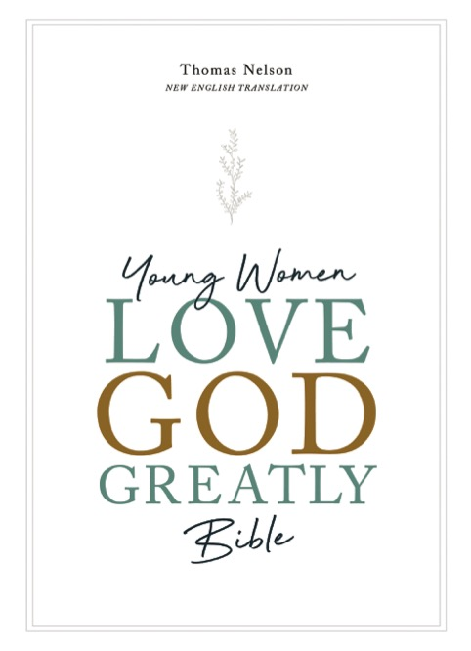
Nashville, TN (November 8, 2021) — Love God Greatly International Women’s Ministry and Thomas Nelson Bibles announce the upcoming release of the Young Women Love God Greatly Bible (March 29, 2022). This new Bible features original content designed for young women ages 13 to 18 years alongside Scripture in the New English Translation (NET). Love God Greatly and Thomas Nelson Bibles previously partnered on the Love God Greatly Bible (2020), which has been well-received.

Angela Perritt, founder of Love God Greatly, explains the organization’s vision for discipling young women globally: “We see younger women around the world hungering to know God and love Him. But where to start? How does a teenager learn to love God greatly? We have designed the Young Women Love God Greatly Bible to function as a unique discipleship companion for young women who want to know God’s Word.”

Love God Greatly exists to help every woman in every nation access God’s Word in her own language. The nonprofit annually publishes seven Bible studies in English, and these are sold at an affordable price to help fund the organization’s global ministry. Each English Bible study is then translated into multiple langues and distributed to women around the globe for free. Since 2014, Love God Greatly Bible studies have reached more than 500,000 women in over 200 countries across 35 different languages.

“One of the most unique facets of Love God Greatly is the local communities of women who study God’s Word together,” says Melissa Fuller, Content Director for Love God Greatly and one of the visionaries behind the Young Women Love God Greatly Bible. “We are modeling both the power of God’s Word and the power of connection. Studying the Bible together and hearing what God is doing worldwide is a remarkable buoy for our faith.”

The Young Women Love God Great Greatly Bible is visually beautiful, featuring colorful full-page hand-lettered Scripture verses as well as 66 first-person testimonies from young women around the world whose lives have been changed by Scripture. Scripture is presented in the readable New English Translation (NET), which was developed to be both accurate and accessible. The translation’s international mission is aligned with goal of Love God Greatly: putting Scripture in the hands of as many readers as possible, as affordably as possible.

Specific features of the Young Women Love God Greatly Bible include:
- Book Introductions & Memory Verses for each book of the Bible;
- 66 Personal Testimonies from Christian women around the world;
- 50 Reading Plans for engaging with Scripture daily using the SOAP method;
- 10 Topical Reading Plans around life’s issues, such as fear and anxiety, truth and lies, and friendship;
- 25 “Letters from a Mentor” articles offer instruction, encouragement, and love from seasoned women of faith;
- 25 “Heroes of the Bible” features which profile women who followed God in a variety of setttings and circumstances;
- 100 Devotions for encouragement and teaching deeper insights about God’s Word;
- Reflection Questions, Challenges, and Journaling Space in the wide margins next to the Scripture text;
- 10 Full-Color original Maps show the Biblical geography in the Old and New Testaments;
- 10 Detailed Timelines display historical events of Israel, the life of Jesus and the early Church;
- 10 Infographics offering additional insights about theology and biblical characters and themes;
- Clear and readable New English Translation (NET) in the 9.5-point “Comfort Print” size.

Philip Nation, Vice President and Publisher of Nelson Bibles believes this Bible will be unique among Bibles designed for young women ages 13-18. “The Young Women Love God Greatly Bible is perfect for Gen Z. This generation is more connected globally and more responsive to beautiful astetics. The thoughtful design of this Bible showcases the power of beautiful design and beautiful testimonies alongside the beauty of God’s Word.”

As of 2021, more than half a million women have participated in a Love God Greatly study. Love God Greatly has more than 360,000 followers on Facebook, 40,000 followers on Instagram—women from all over the world who are longing for a community of other women to help inspire and encourage them in their faith. Love God Greatly’s mission is to help women love God greatly with their lives . . . one Bible study, one translation, one woman at a time as they fight against Biblical illiteracy.

About Love God Greatly: Love God Greatly was started in 2014 with the desire to help every woman in every nation have access to God’s Word in her own language. Love God Greatly has developed a team of trained translators who have translated more than 50 Bible studies into 35+ languages, all offered free or at low cost. Love God Greatly has reached more than 200 countries around the world. For more information, visit www.LoveGodGreatly.com

About Thomas Nelson: Thomas Nelson is a world leading publisher and provider of Christian content and has been providing readers with quality inspirational product for more than 200 years. As part of HarperCollins Christian Publishing, Inc., the publishing group provides multiple formats of award-winning Bibles, books, gift books, cookbooks, curriculum and digital content, with distribution of its products in more than 100 countries. Thomas Nelson is headquartered in Nashville, TN. For additional information visit www.thomasnelson.com.

###

Young Women Love God Greatly Bible
Editors: Angela Perritt and Melissa Fuller
Available from Thomas Nelson
March 29, 2022

Price: U.S. $49.99 & up Format: Various Pages: 2240
LEATHER ISBN-13: 978-07852-3886-7
HARDCOVER ISBN-13: 978-07852-3885-0
BISAC category: Religion / Christian Life / Spiritual Growth

Review copies, reprint permission and interviews are available.
Contact Jana Muntsinger, McClure Muntsinger Public Relations, 832.247.9308, jana@mmpublicrelations.com

November 8, 2021

